Appendix 1: Leisure Sites in Oxford
Click here for the on-line version with key for each leisure offer type.

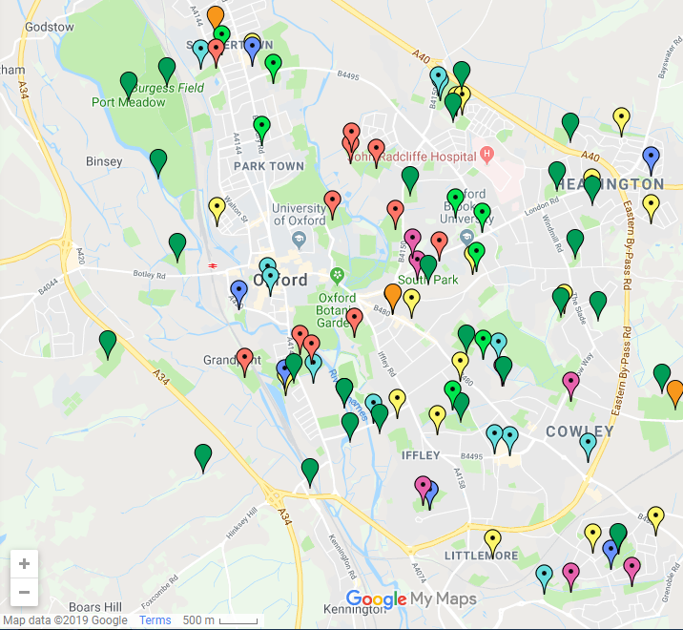
Summary key
Oxford Council Leisure centres Commercial Gyms & Leisure Clubs

Community Centres GO Active Fit Trails (Free of charge)

Outdoor Courts and other Venues Parks & Nature Reserves

Schools University Sites

